Chapter 11, Problem 26.

Find the effective value of the voltage waveform in Fig. 11.57.

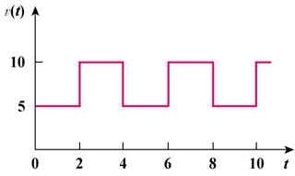
20
10

Figure 11.57
For Prob. 11.26.

